RF Waveform Generator

Brian Chau

Daniel Hickl

Eugene Asare

Khoi Le

**System Reports**

Subsystem Reports

for

RF Waveform Generator

Prepared by:

_____________________________

Author Date

Approved by:

_____________________________

Project Leader Date

_____________________________

John Lusher, P.E. Date

_____________________________

T/A Date

**Change Record**

| **Rev.** | **Date** | **Originator** | **Approvals** | **Description** |
| --- | --- | --- | --- | --- |
| **-** | 11/24/24 | RF Waveform Generator |  | Draft Release |

**Table of Contents**

**1. Overview 6**

**2. Development Plan and Execution 6**

2.1 Execution 7

2.2 Testing Methodology 7

2.3 Validation Plan 10

**3. Testing Results 11**

3.1 Power System Readings 11

3.2 Spectrum Analyzer - DC Vtune 11

3.3 Oscilloscope - Modulation Vtune 14

3.4 IF Frequency Calculations 14

**Appendix A: Acronyms and Abbreviations 16**

**Appendix B: Definition of Terms 17**

**List of Tables**

**Table** **1.Power System Requirements** **10**

**Table 2. Modes of Operation****10**

**Table 3. Power System Results** **11**

**Table 4. *Spectrum Analyzer Validation Results* 14**

**Table 5. IF Frequency Calculations and Results 16**

**Table 6. SWAP-C Goal 18**

**List of Figures**

**Figure 1. System Design Methodology** **6**

**Figure 2. Integration Method 1 PCB Layout** **7**

**Figure 3. Integration Method 2** **8**

**Figure 4. Signal Mixing Diagram** **9**

**Figure 5. Expected IF Signal** **9**

**Figure 6. RF Signal and Time Delayed Signal** **10**

**Figure 7. 0V Tuning Voltage Output** **12**

**Figure 8. 4V Tuning Voltage Output 12**

**Figure 9. 13V Tuning Voltage Output** **13**

**Figure 10. 1k Hz Modulation Mode** **13**

**Figure 11. 5k Hz Modulation Mode 13**

**Figure 12. 10k Hz Modulation Mode** **14**

**Figure 13. 1k Hz Modulation Mode** **15**

**Figure 14. 5k Hz Modulation Mode** **15**

**Figure 15. 10k Hz Modulation Mode 16**

**Figure 16. 10k Hz (Single Period) 16**

**Figure 17. Fully Integrated PCB Assembly 17**

**Figure 18. VCO Frequency vs Vtune Plot 18**

**Figure 19. Analog Drive DAC Output 18**

# **Overview**

The RF Waveform generator is a low SWAP-C (size, weight, power, and cost) frequency synthesizer that produces a sawtooth RF signal from 1.6 to 3.2 GHz. The system consists of 4 different subsystems: Power, Analog Drive, RF, and Signal Mixing/Testing. These four different subsystems were integrated together and validated to create a working product meeting all project specifications. This will serve as a simple and cost-effective method of mass-producing RFwaveform generators for various communication applications.

# **Development Plan and Execution**

One of the main goals in this project was to minimize costs and resources, as current systems of RF Waveform Generators are expensive, complex, and resource-heavy in mass production. In this design system, an Analog Drive (using a microcontroller) creates a sinusoidal tuning voltage to the Voltage-Controlled Oscillator which outputs the RF signal. The Power subsystem will take a power source of 2 AA batteries and distribute power to all of the necessary components, which can be measured and displayed on an interface by the GUI/ Monitor Subsystem. Ideally, once the separate subsystems PCB’s are created, all four subsystems can be combined into one 2x2 inch PCB that operates fully on its own. Compared to other alternative methods and designs, this design is the simplest and most cost-effective product that still meets all the project requirements.

*Figure 1. System Design Methodology*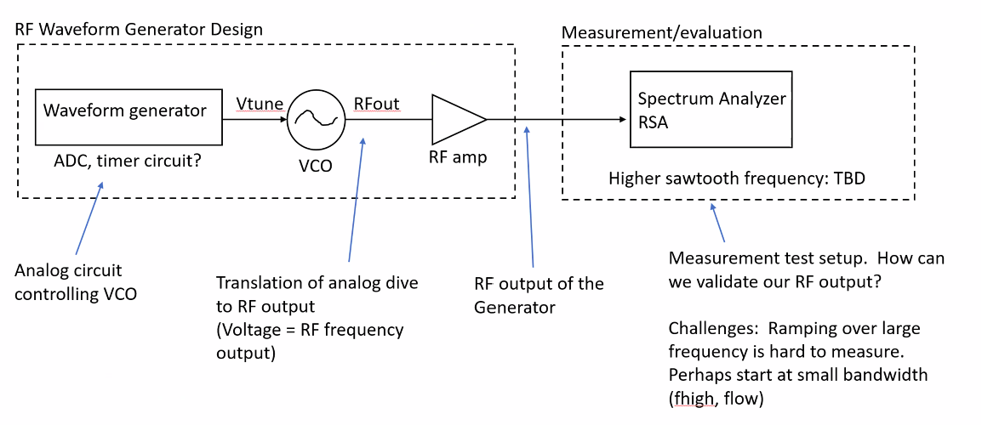

## **2.1 Execution**

Before any integration can be done, the first step is to first finalize the individual subsystems from the previous semester. With this project being almost entirely composed of hardware, this mainly involved debugging PCB’s, validating signal readings on oscilloscopes/ spectrum analyzers, and correcting/ adding updates onto Altium to prevent those issues from occurring again. During this step in the project, a key decision was made to eliminate the GUI/ Monitor Subsystem. After discussing with the professor and project sponsor, it was agreed that this subsystem wasn’t needed and caused unnecessary integration difficulties that actually contradicts the scope of the project. Instead, this was replaced by the Signal Mixing/ Testing subsystem, which is focused on creating a Signal Mixer for testing. In short, current testing equipment wasn't equipped with measuring RF signals of this frequency range, hence leading to the creation of this new subsystem to find and implement an alternative testing methodology. Refer to CONOPS for the full subsystem description.

Once the systems were fully assembled and functional, two separate integration methods were implemented. The first integration method was to connect the 4 PCBs together. The Power board provided power to the RF and Analog Drive boards, and the tuning voltage produced by the Analog Drive connected as the input to the RF board. From there, the output of the RF board would be split into two connections, one going into the RF port of the Signal Mixer, another going into the LO port. The Signal mixer would essentially ‘mix’ the two signals, creating a sine wave that can be measured in the oscilloscope. This testing method utilizes Pulse Compression, which drives down the RF signal to a frequency range that could be measured using the testing equipment in the lab.

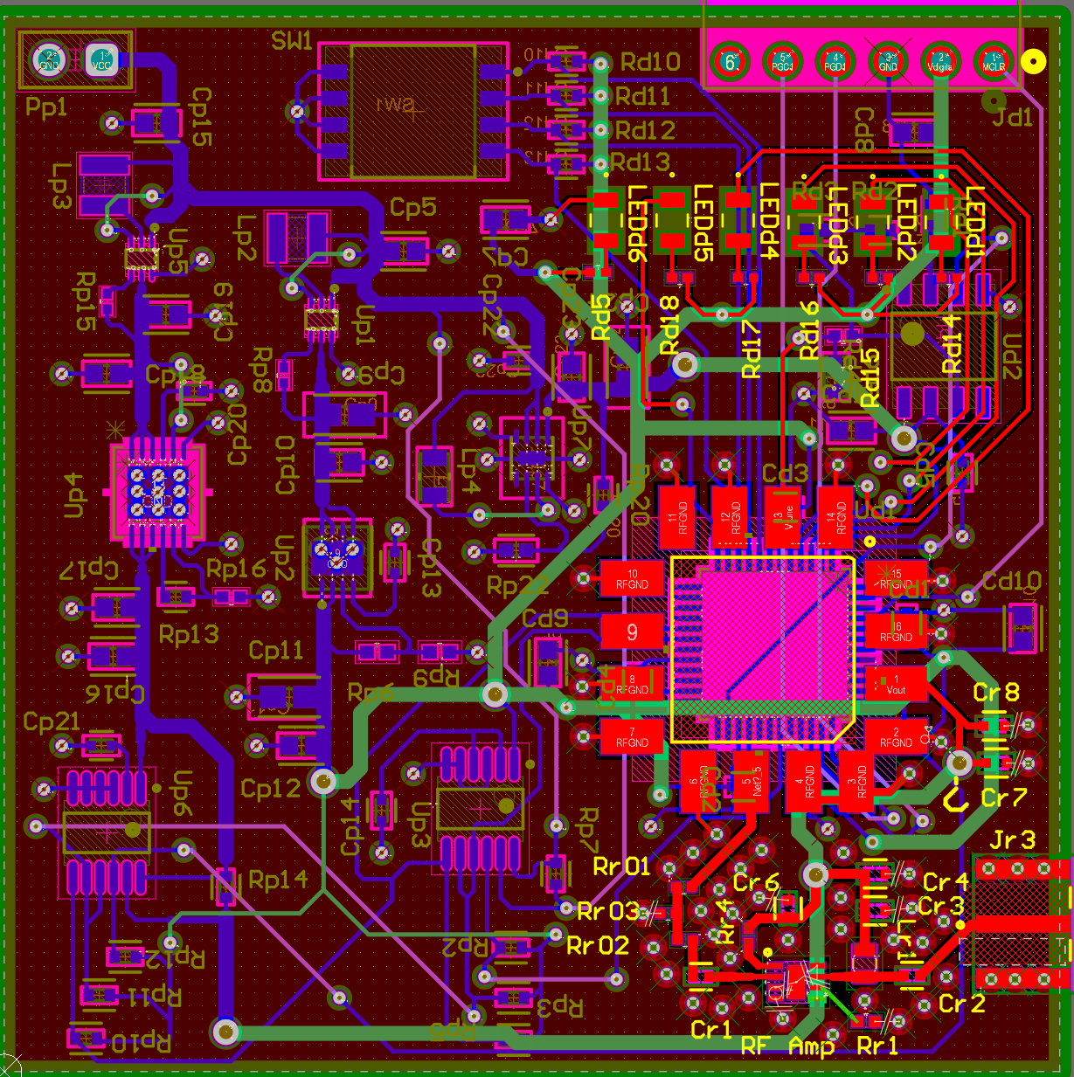

*Figure 2. Integration Method 1 PCB Layout*

The second integration method is full hardware integration of the subsystem. In other words, it means combining the Analog Drive, RF, and Power PCBs into one, 2x2 inch PCB. The small size requirement requires a complete redesign on Altium, adding three subsystems together while reconfiguring them in such a way in which all components can fit into the PCB. This PCB would be eight layers and double-sided; top side being the RF layer, the bottom side being the other analog components since RF requires additional rules and constraints in PCB design. The connections made in integration method 1 will be directly connected via PCB traces in this integration method. Again, since the Signal Mixer/ Testing subsystem is only used for validating the system it will be isolated in its own separate PCB.

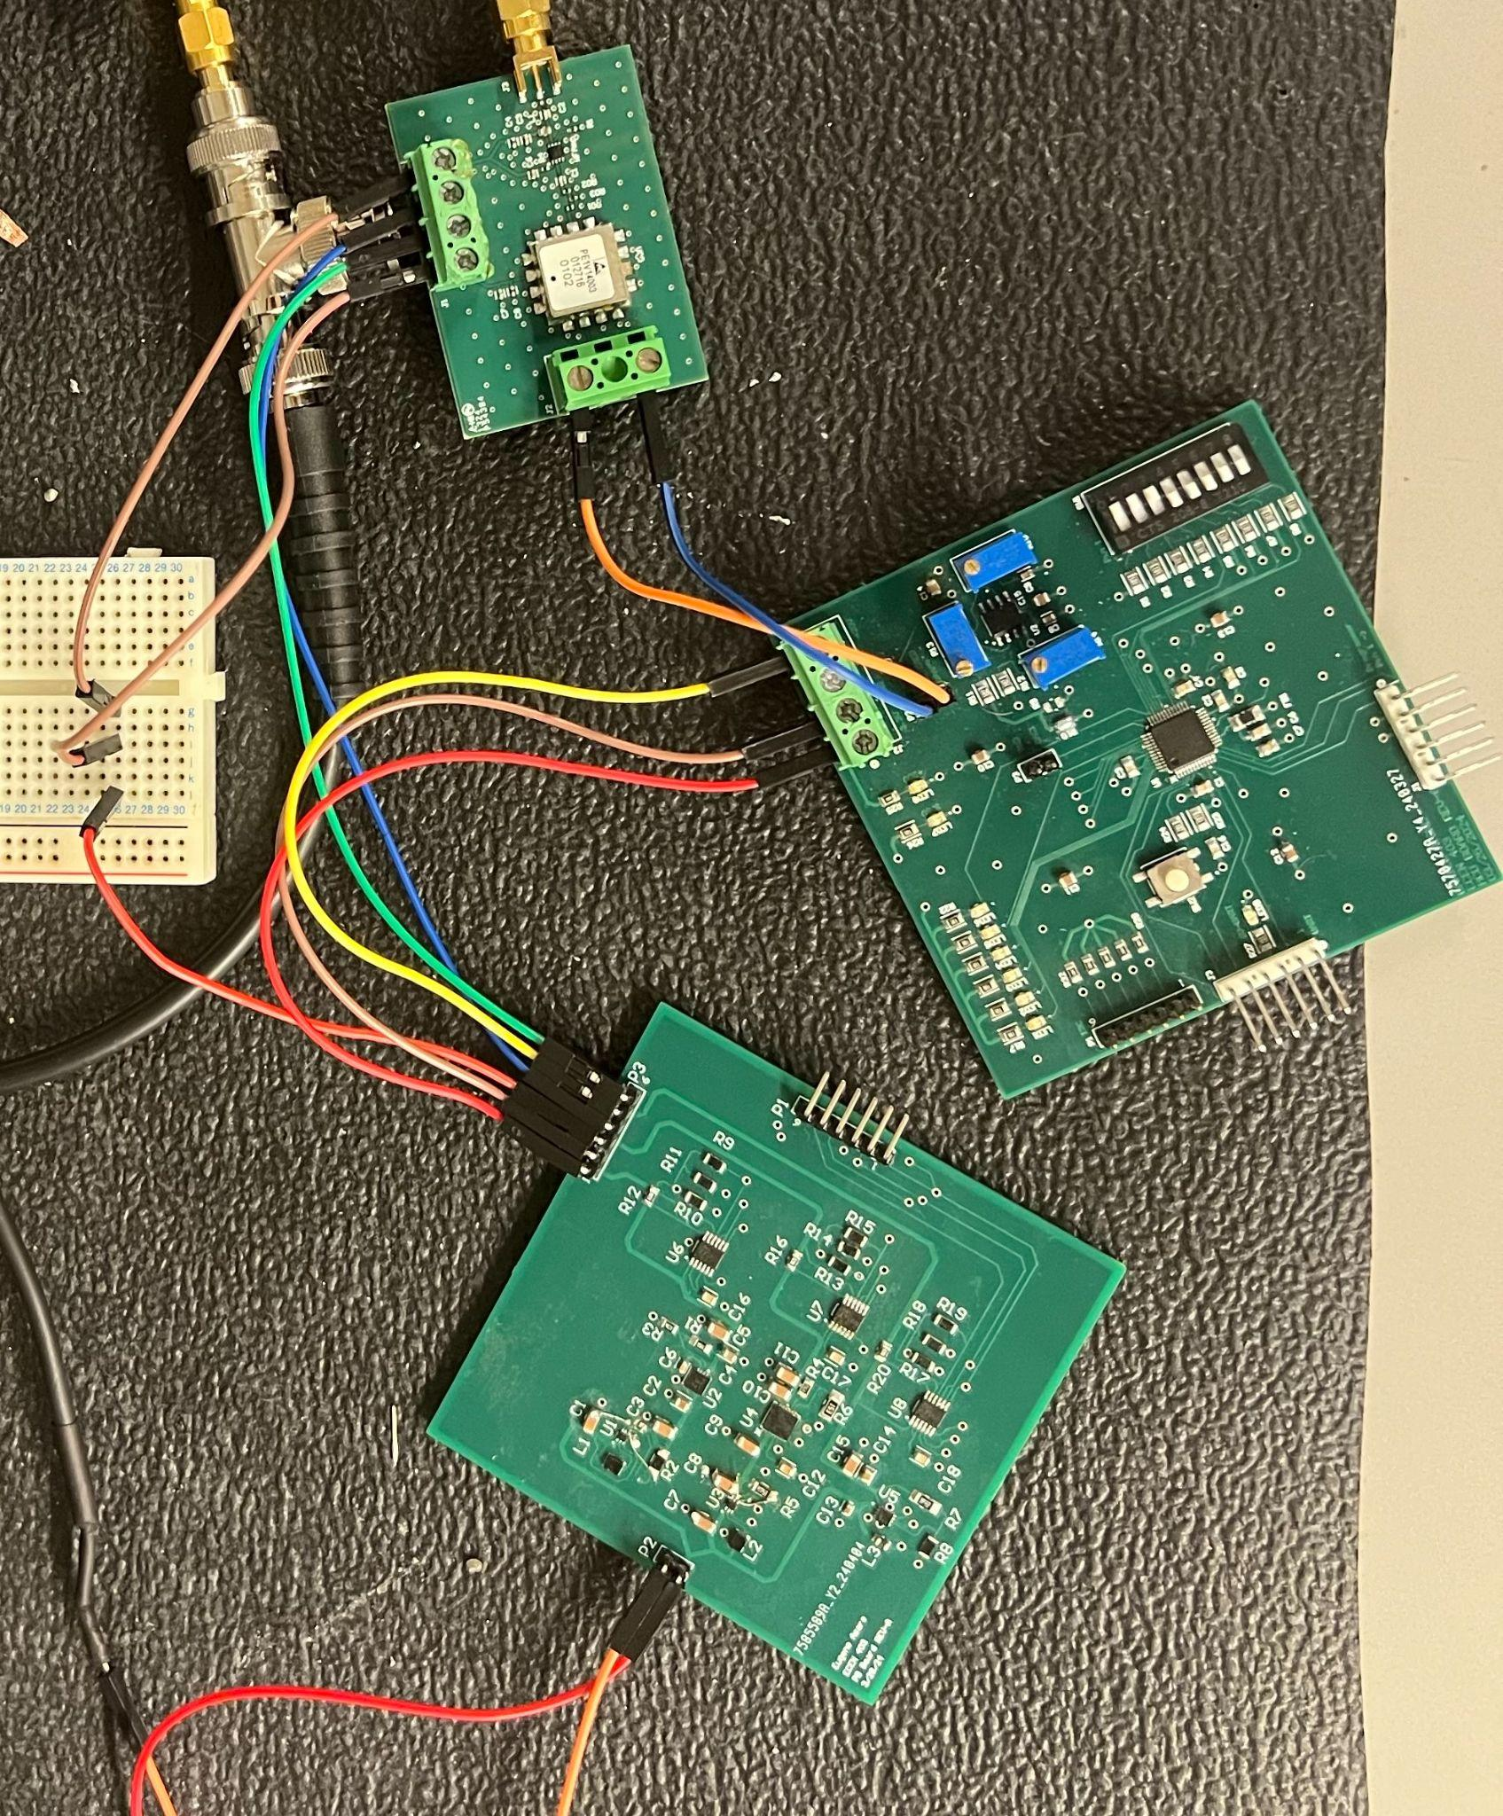

Figure 3. Integration Method 2

## **2.2 Testing Methodology**

Due to the insufficiency of the electromagnetic lab equipment, the new testing subsystem was created. Since the spectrum analyzer in this lab does not have a high enough sampling rate, a couple different techniques were used to test our integrated system. The first test was to ensure that the frequency of our generator was producing a signal that was between 1.6GHz and 3.2GHz. This test could be done on the spectrum analyzer. The second test was to ensure that the chirp rate during our modulation states was constant. To do this, one must use a signal splitter along with a signal mixer and measure this output on an oscilloscope. The signal mixer has two inputs: RF and LO. The RF output of the integrated system will be split using a signal splitter. One side will go to the RF input of the mixer, while the other will be connected to a long coaxial cable. This is intended to create a time delayed signal which will go into the LO input of the mixer. The signal mixer would then perform a “downconversion mix”, where it will process the two signals into one output signal called IF port. That IF frequency would be the difference between the signals of the RF and LO inputs. When downconversion is performed, this signal mixing will drive down the IF to a frequency range low enough to be measured with current lab equipment. This was the biggest issue encountered during the validation process, and this method enables us to continue testing without having to outsource or potentially purchase further testing equipment.

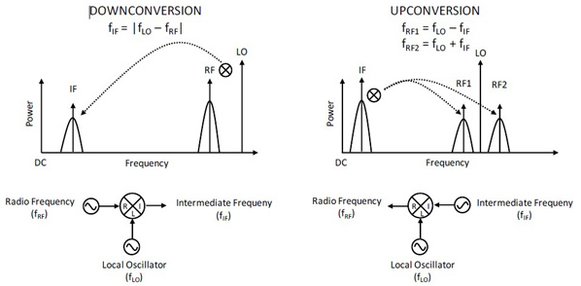

*Figure 4. Signal Mixing Diagram*

From the IF frequency, an oscilloscope can be used to visualize the signal. Figure 3 below exemplifies the expected output, as it should be a sine wave that is periodic and in wave packets. The wave packets indicate that the modulation from the Vtune is periodic, and the period of those wave packets correspond to the frequency of the tuning voltage.

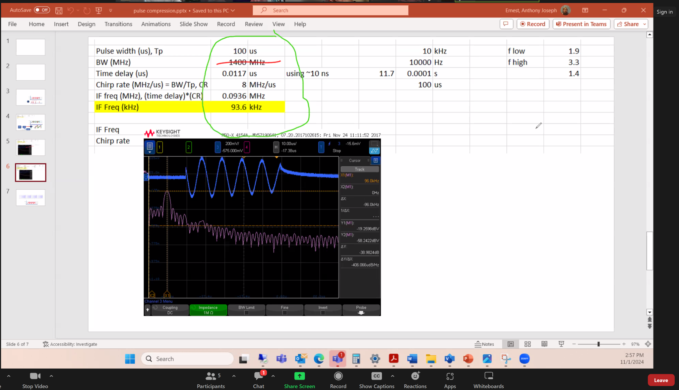

*Figure 5. Expected IF Signal*

To finally prove that the RF waveform generator produces a sawtooth RF signal, the frequency of the IF signal has to be taken and analyzed. Figure 4 below displays the RF signal (red) as well as its time-delayed signal (blue) going into the signal mixer. If both signals are oscillating at a constant and linear rate, then the frequency of the IF signal should also be constant since it’s the difference between the two frequencies. Otherwise, it would be either constantly changing (nonlinear) or it would be zero (not modulating). Therefore, by showing that the IF frequency is non-zero and constant, the RF signal would be a sawtooth waveform.

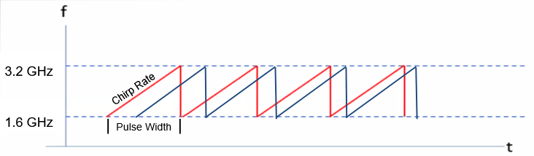

*Figure 6. RF Signal and Time Delayed Signal*

Moreover, through some properties of pulse compression, the IF frequency is also proportional to the chirp rate of the tuning voltage. With a known bandwidth and fixed pulse width, the chirp rate (slope of oscillation) can be calculated by dividing the bandwidth by the pulse width. The IF frequency can then be found by multiplying the time delay by the chirp rate, showing that the signal is properly oscillating at the intended bandwidth.

## **2.3 Validation Plan**

The validation plan of the RF Waveform Generator can be split into three different categories: Power, DC Tuning Voltage, and Modulation. The first table is the Power readings to the VCO, RF Amplifier, and MCU, showing the target range of voltage/current readings in which the system can operate at.

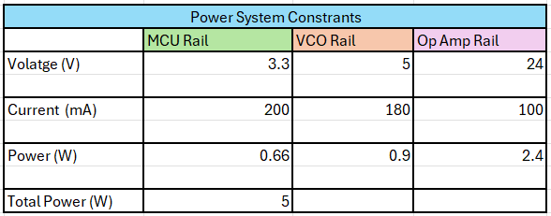

*Table 1. Power System Requirements*

The second part of validation is DC Tuning Voltage on the Spectrum Analyzer. To validate that the RF signal spans from 1.6 to 3.2 GHz, its modes of operations shown below will be used to test for the proper RF frequencies of the system. For example, if the DAC is in mode 3, it should produce a DC voltage signal of 7 V and an impulse function should appear on the spectrum analyzer at 2.4 GHz (spectrum analyzer plots magnitude over frequency).

| Mode | Mode Type | Input Tuning Voltage (V) | Output Rf Frequency (GHz) |
| --- | --- | --- | --- |
| 1 | DC | 0 (OFF) | 1.6 |
| 2 | DC | 4 | 2 |
| 3 | DC | 7 | 2.4 |
| 4 | DC | 10 | 2.8 |
| 5 | DC | 20 | 3.2 |
| 6 | Modulation | Mod at 1kHz | 1.6 - 3.2 |
| 7 | Modulation | Mod at 5kHz | 1.6 - 3.2 |
| 8 | Modulation | Mod at 10kHz | 1.6 - 3.2 |

*Table 2. Modes of Operation*

One thing to note, when the MCU is in modulation, the spectrum analyzer will not produce an impulse function. Since the resulting voltage signal is oscillating between 1.6 - 3.2 GHz at rate faster than the sampling rate of the spectrum analyzer, the expected result would be a step function from 1.6 to 3.2 GHz, capturing all the frequencies in which the signal oscillates between.

# **Testing Results**

## **3.1 Power System Readings**

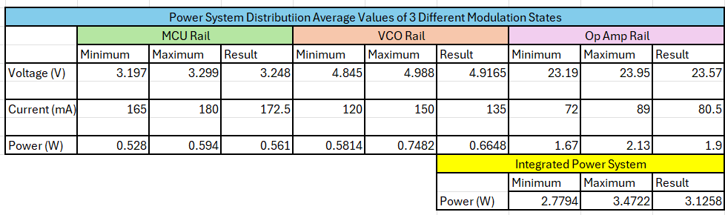

*Table 3. Power System Results*

The table above shows the power readings of the integrated system when operating the three different modulation modes. In total we see that the result of the testing is within the required power system ratings.

## **3.2 Spectrum Analyzer - DC Vtune**

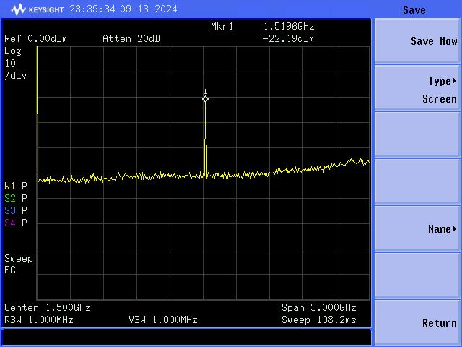 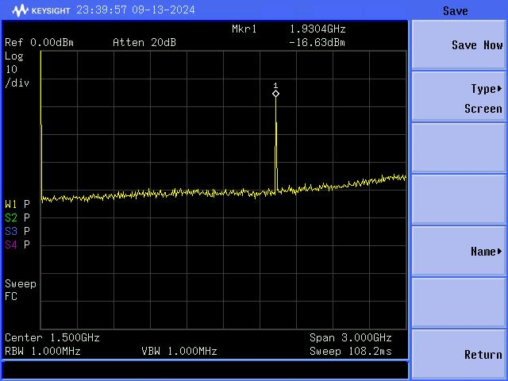

*Figure 7. 0V Tuning Voltage Output Figure 8. 4V Tuning Voltage Output*

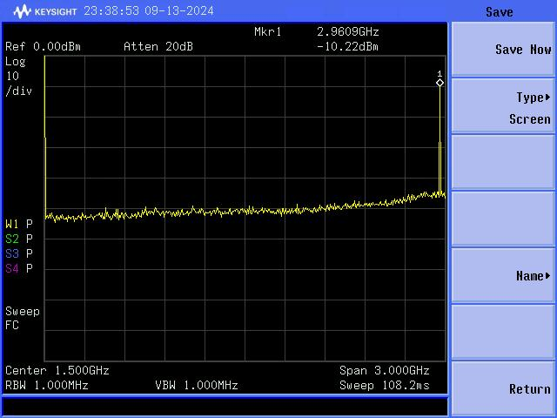

*Figure 9. 13V Tuning Voltage Output*

The results of the figures are checking to make sure our frequency range is between 1.6 to 3.2 GHz. With the state off we see that we get an output frequency of about 1.6 GHz and as we continue through the different graphs, we see that our range increases to our desired output frequency of 3.2 GHz. In the figures we see that we have only 3 single DC frequency states of this generator. Note that in the last figure there is no spike showing the frequency above 3 GHz. This is because of the limitation of the spectrum analyzer not being able to read values up to 3 GHz.

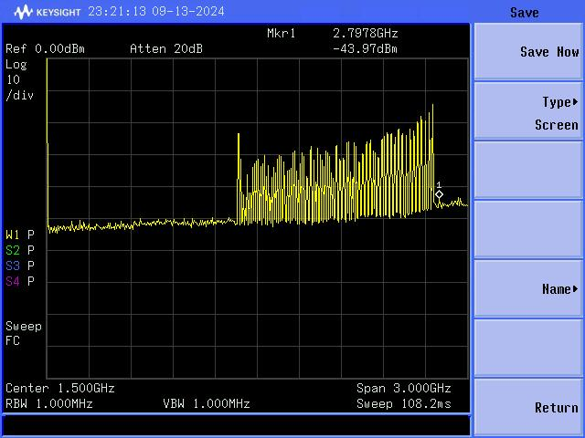 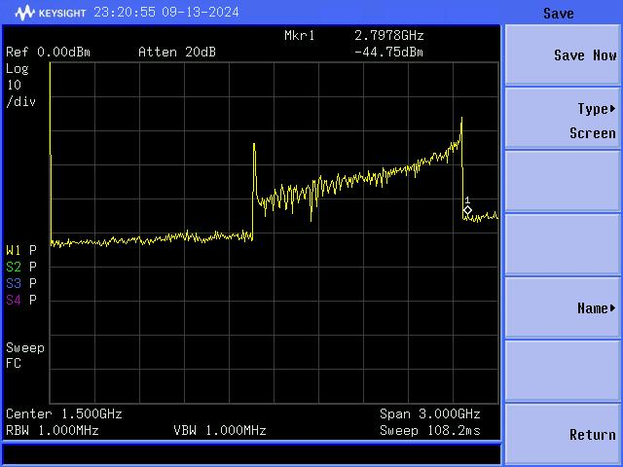

*Figure 10. 1k Hz Modulation Mode Figure 11. 5k Hz Modulation Mode*

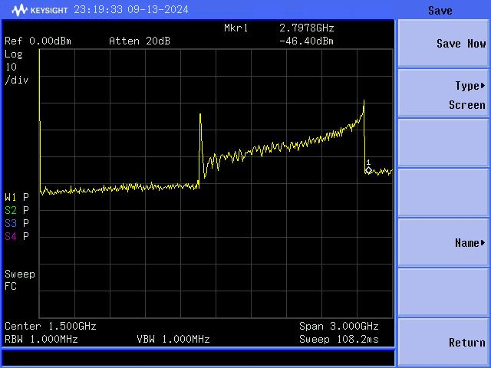

# *Figure 12. 10k Hz Modulation Mode*

The next set of figures show what happens when we change states, and we see a complete range of frequencies. This means that all these frequencies from 1.6 to 3.2 are on and active during this mode. Since this is a modulation state, we are expecting to see this because our system is going to take on many different frequencies between 1.6 to 3.2 at an analog drive frequency at 1k Hz in Figure 8.

| Mode | Mode Type | Input Tuning Voltage (V) | Expected Output Rf Frequency (GHz) | Average Measured Output Rf Frequency (GHz) |
| --- | --- | --- | --- | --- |
| 1 | DC | 0 (OFF) | 1.6 | 1.56 |
| 2 | DC | 4 | 2 | 1.97 |
| 3 | DC | 7 | 2.4 | 2.45 |
| 4 | DC | 10 | 2.8 | 2.90 |
| 5 | DC | 20 | 3.2 | 3.0 (Max) |
| 6 | Modulation | Mod at 1kHz | 1.6 - 3.2 | 1.590 - 3.0 (Max) |
| 7 | Modulation | Mod at 5kHz | 1.6 - 3.2 | 1.594 - 3.0 (Max) |
| 8 | Modulation | Mod at 10kHz | 1.6 - 3.2 | 1.603 - 3.0 (Max) |

*Table 4. Spectrum Analyzer Validation Results*

Note: 3GHz is the highest the spectrum analyzer can measure.

## **3.3 Oscilloscope - Modulation Vtune**

# 

# *Figure 13. 1k Hz Modulation Mode**Figure 14. 5k Hz Modulation Mode*

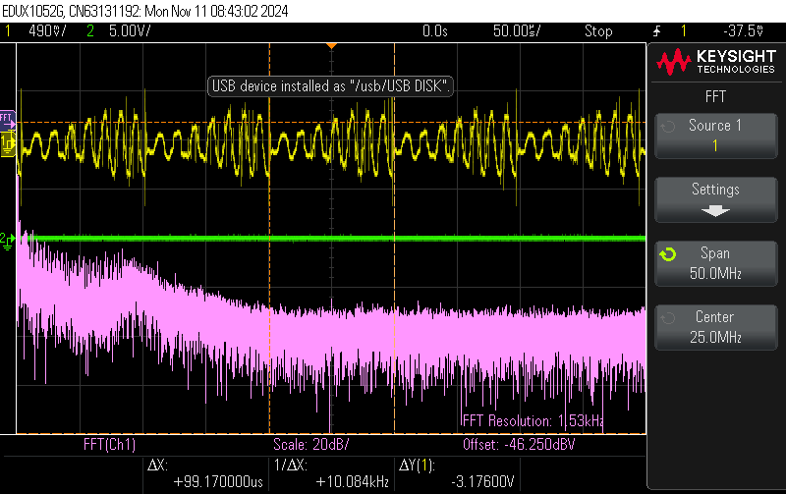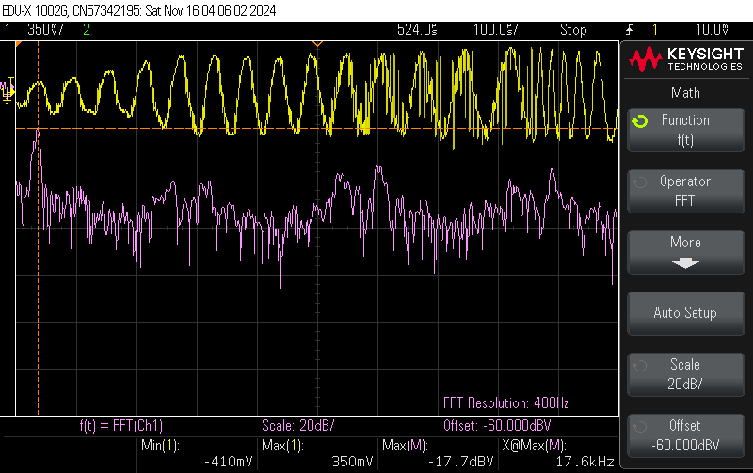

# *Figure 15. 10k Hz Modulation Mode Figure 16. 10k Hz (Single Period)*

In the above figures we are seeing the output of the VCO that is given through our mixer in order to check the validity of the output signal. Focusing on the 1k Hz modulation we see in the yellow line that the time period of signal matches that of the modulation of 1k Hz. The pink FFT is showing the kHz frequency in modulation.

## **3.4 IF Frequency Calculations**

Figure 15 below details the calculations for IF frequencies given the frequency of the tuning Voltage (PRF). Drawing from the table above with these calculations, the RF signals are generally accurate to the expected results, thus proving that the RF signal of the system spans from 1.6-3.2 GHz and is a linear, sawtooth waveform.

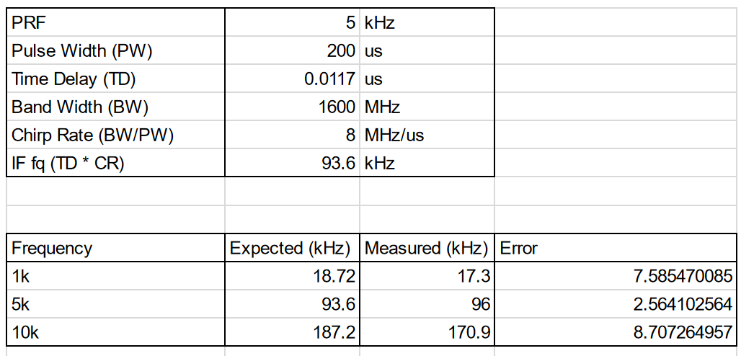

Table 5. IF Frequency Calculations and Results

# **Final Reflection**

## **4.1 Key Decisions**

Throughout the development of this project, there were two key decisions that were made. The first one was the creation of the new Testing Subsystem. At the end of last semester when the Electromagnetics lab was finally available, we found out that the lab didn’t have proper lab equipment that can support the frequency range of the project. At the same time, discussions were made with our project sponsor that Khoi’s GUI subsystem was unnecessary and out of the scope of the project. Therefore, it was decided that Khoi’s GUI subsystem would be scratched for the new Testing subsystem, one that is essential for project demo and proceeded with that instead.

Additionally, significant integration progress was made on the single, fully integrated PCB board. However, during testing/validation, we found an issue on the PCB that turned out to be a design error on the Altium PCB Layout. For two components on the backside of the assembly board, the footprint somehow didn’t get inverted as it switched to the backplane, creating a bug that couldn’t be fixed in due time. Due to the timeline of the project and the amount of time it would take to fix it, we decided to proceed with the individual boards instead (integration method 1) to complete the project. Figure 15 and 16 below are the PCB layout of the single integrated board and the progress up until that decision.

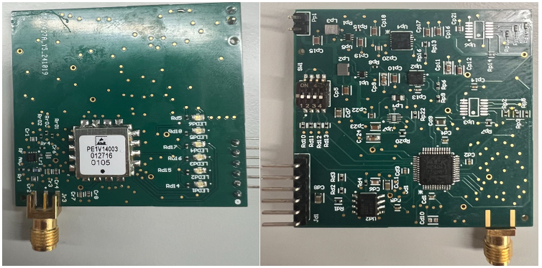

*Figure 17. Fully Integrated PCB Assembly*

## **4.2 Areas of Improvement**

One major improvement that can be made with our goal of low SWAP-C is the size aspect of our boards. Although the single PCB had to be set aside to ensure project completion, it could be reordered with the fixed changes to fit the size criteria. Additionally, to increase accuracy of the IF frequency and model a perfect sawtooth waveform, the tuning voltage can be adjusted to more perfectly fit the VCO specifications. In Figure 18 below, the iRF frequency isn’t exactly linear to the input tuning voltage. With more time and testing, fine tuning of this generator could be done to decrease the error in the system. Towards the higher end of the tuning voltage, RF frequency flattens out. In order to ensure a perfectly linear RF signal, a linear regression would have to be done on Figure 18 to approximate the rate of change.

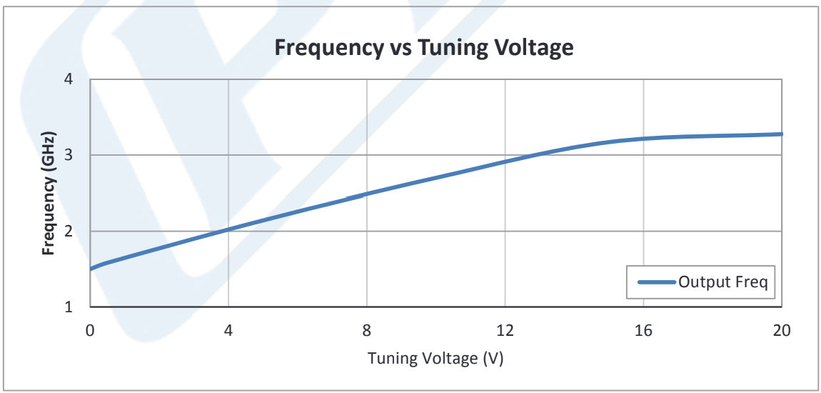

Figure 18. VCO Frequency vs Vtune Plot

From there, a look-up table would be created from that approximation to create a ramp-up tuning Voltage that has a constant rate of change.

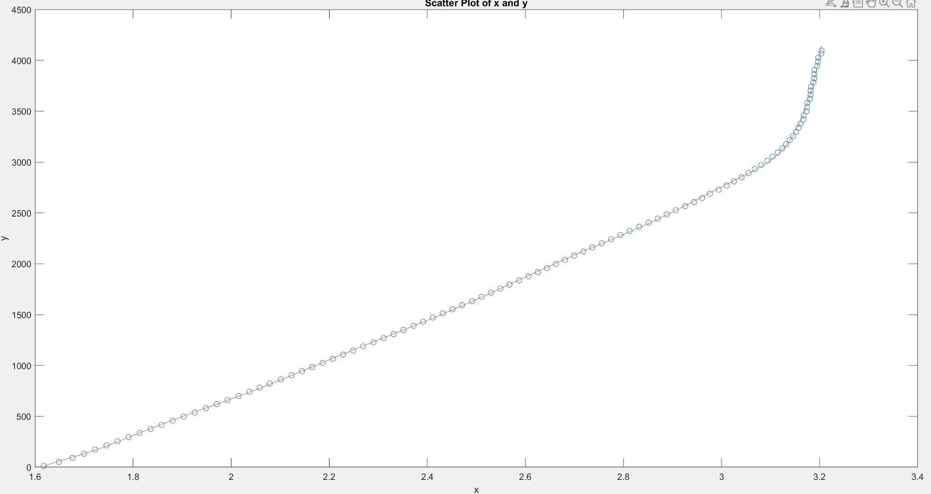

Figure 19. Ideal Analog Drive DAC Output

## **4.3 Conclusion**

With the decision of moving forward with the first integrated configuration, many but not all of the project requirements were met. The two key requirements of this project were the generation of a linear sawtooth RF waveform and low SWAP-C. We were successful in creating a linear sawtooth waveform in the required frequency range. Although, we were not fully successful in the low SWAP-C requirement. As seen in figure 16 below, all of these specifications were met except the size requirement. Completion of the second integrated configuration would meet this requirement.

After discussions with our sponsor, Mr. Anthony Ernest, the RF Waveform Generator was deemed a successful project, fulfilling the goal of pushing the boundaries of RF board design and RF waveform generation.

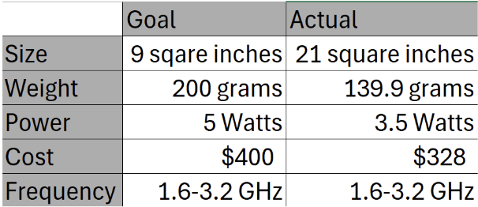

Table 6: SWAP-C Goals

# 

# **Appendix A: Acronyms and Abbreviations**

µC Microcontroller

DAC Digital to Analog Converter

DIP Dual In-Line Package

GHz Gigahertz (1,000,000,000 Hz)

GUI Graphical User Interface

IF Intermediate Frequency - Signal Mixer Output

LDO Low Dropout Regulator

LO Local Oscillator - Signal Mixer Input

MCU Microcontroller Unit

Op amp Operational Amplifier

PCB Printed Circuit Board

R&D Research and Development

RF Radio Frequency

SWAP-C Size Weight and Power - Cost

USB Universal Service Bus

VCO Voltage-Controlled Oscillator

VDC Volts Direct Current

# **Appendix B: Definition of Terms**

| DC-DC Boost Converter | A device with a higher output voltage than input voltage. AKA a step-up converter because it “steps up” the voltage. |
| --- | --- |
| Digital to Analog Converter | A device that translates digitally stored information from a computer or phone into an analog sound that we can hear. |
| DIP Switch | Consists of a small block of switches mounted on a dual in-line package. Each switch corresponds to a specific binary digit. Using the switch on the PCB provides flexibility in configuration. |
| Chirp Rate | Rate of change in which the tuning voltage oscillates. This is also the slope of the sawtooth waveform. |
| Graphical User Interface | A type of user interface that allows users to interact with a device or software via graphical components such as buttons, menus, windows, or text-based interfaces. |
| IF Frequency | IF signal is the output of the signal mixer, and the frequency of the IF signal is the difference between the RF and LO inputs of the mixer. |
| Low Dropout Regulator | A device that takes an input voltage from a power supply and uses that input to output a steady voltage. |
| Voltage-Controlled Oscillator | An RF oscillator circuit whose frequency can be controlled by a DC input voltage. |